ENTITY-RELATIONSHIP MODEL

Practice Solutions
Instructor answer key. Model answers are shown for reference — accept reasonable equivalent wording from students.

Question 1 ✓ Model Answer
A university maintains information about students. Each student has a student ID, name, date of birth, email address, and major. The university stores thousands of student records.
a. Identify the entity
• Student
b. Provide three examples of entity instances
• Student ID 10001: John Smith
• Student ID 10002: Maria Lopez
• Student ID 10003: David Chen
c. Identify five attributes of the entity
• StudentID
• StudentName
• DateofBirth
• EmailAddress
• Major
d. Explain the difference between an entity and an entity instance
• An entity represents a category of objects being modeled (Student).
• An entity instance represents one specific occurrence of that entity (John Smith with StudentID 10001).
Question 2 ✓ Model Answer
A customer database stores the following attributes. Classify each attribute as Atomic or Composite, and Stored or Derived, and explain your rationale.
Attribute | Classification (Atomic/Composite, Stored/Derived) | Rationale
CustomerID | Atomic, Stored | A single value used to identify a customer
CustomerName | Atomic or Composite (dependent on company type), Stored | Can be stored as one value or divided into first/last name
CustomerAddress | Composite, Stored | Contains street, city, province, postal code
DateofBirth | Atomic, Stored | Stored directly in the database
Age | Atomic, Derived | Calculated from DateofBirth
AccountBalance | Atomic, Stored/Derived | Maintained directly as a database value depending on other data
PhoneNumber | Atomic, Stored | Treated as a single data element

Question 3 ✓ Model Answer
Analyze the following relationships and identify whether each relationship is One-to-One, One-to-Many, or Many-to-Many.
a. A customer can place many orders
• One-to-Many
b. A student can enroll in many courses
• Many-to-Many
c. Each employee has one company parking permit
• One-to-One
d. Each department has many employees
• One-to-Many
Question 4 ✓ Model Answer
A university bookstore tracks textbooks, authors, publishers, and sales transactions.
a. Identify four possible entities
• Textbook
• Author
• Publisher
• Sale
b. Explain why each item qualifies as an entity
• Textbook: the bookstore needs to store information about individual textbooks, such as title, ISBN, price, and edition.
• Author: authors are distinct people about whom the bookstore may store information, such as name and contact or biographical details.
• Publisher: publishers are separate organizations associated with textbooks and may have their own identifying information, such as name and address.
• Sale: each sales transaction represents a separate business event that the bookstore needs to record, such as sale date, total amount, and payment method.
c. Identify one possible instance of each entity
• Textbook: Database Systems
• Author: Carlos Connolly
• Publisher: Pearson
• Sale: #10542 completed on August 14, 2026
Question 5 ✓ Model Answer
A medical clinic stores information about patients. Determine whether each item is an entity or an attribute and explain your rationale.
a. Patient
• Entity — represents the people whose information is stored
b. PatientName
• Attribute — describes a patient
c. InsuranceCompany
• Entity — may require separate information storage
d. Appointment
• Entity — represents scheduled visits
e. PhoneNumber
• Attribute — describes a patient
f. Physician
• Entity — represents healthcare providers
Question 6 ✓ Model Answer
Analyze the following relationships and identify the relationship type, the parent entity, the child entity, and explain whether an associative entity is required.
a. A person has one passport. A passport belongs to one person.
Relationship Type | One-to-One
Parent Entity | Person
Child Entity | Passport
Associative Entity Required? | No
• Each Person is related to only one Passport, and each Passport is related to only one Person. A foreign key can be placed in the Passport entity to reference Person. An associative entity is not required because there is no many-to-many relationship.
b. A department employs many employees. Each employee works for one department.
Relationship Type | One-to-Many
Parent Entity | Department
Child Entity | Employee
Associative Entity Required? | No
• One Department can employ many Employees, while each Employee belongs to only one Department. The primary key from Department would be stored as a foreign key in Employee. An associative entity is not required.
c. A student can enroll in many courses. Each course can contain many students.
Relationship Type | Many-to-Many
Parent Entity | Student and Course
Child Entity | The associative entity, e.g. Enrollment
Associative Entity Required? | Yes
• A Student can be related to many Courses, and a Course can be related to many Students. A many-to-many relationship cannot normally be implemented directly in a relational database, so an associative entity such as Enrollment is required. Enrollment would contain StudentID and CourseID as foreign keys, used together as a composite primary key.
d. A vehicle has one assigned license plate. A license plate belongs to one vehicle.
Relationship Type | One-to-One
Parent Entity | Vehicle
Child Entity | LicensePlate
Associative Entity Required? | No
• Each Vehicle is assigned one LicensePlate, and each LicensePlate belongs to one Vehicle. A foreign key can be placed in the LicensePlate entity to reference Vehicle. An associative entity is not required because the relationship is one-to-one.
Question 7 ✓ Model Answer
A company stores employee information:
EmployeeNumber
SocialInsuranceNumber
EmployeeName
HireDate
a. Select the best primary key
• EmployeeNumber — it is unique, stable, and created specifically to identify employees
b. Explain why the other attributes are not ideal primary keys
• SocialInsuranceNumber may be unique but is sensitive personal information.
• EmployeeName is not guaranteed to be unique.
• HireDate can contain duplicate values.
Question 8 ✓ Model Answer
Analyze the following business rules and identify whether each relationship is One-to-One, One-to-Many, or Many-to-Many.
a. Each vehicle has one VIN number
• One-to-One
b. A customer can submit multiple support tickets
• One-to-Many
c. A movie can have many actors, and an actor can appear in many movies
• Many-to-Many
Question 9 ✓ Model Answer
A music streaming service stores artists and songs with the following business rules: an artist can create many songs, a song can have many artists, and each song must track the artist's contribution.
a. Identify the many-to-many relationship
• The many-to-many relationship is between Artist and Song — an Artist can create many Songs, and a Song can be created by many Artists.
b. Create an associative entity to resolve the relationship
• ArtistSong resolves the relationship: Artist is one-to-many to ArtistSong, and Song is one-to-many to ArtistSong.
c. Identify the primary key of the associative entity
• The primary key of ArtistSong is a composite key of ArtistID and SongID, ensuring the same Artist/Song combination cannot be entered more than once.
d. Identify all foreign keys
• ArtistSong.ArtistID references Artist.ArtistID.
• ArtistSong.SongID references Song.SongID.
Question 10 ✓ Model Answer
A restaurant tracks customer reservations. A reservation may use one or more dining tables, and a dining table may be used for many reservations over time. Given the following ERD, answer the corresponding questions:
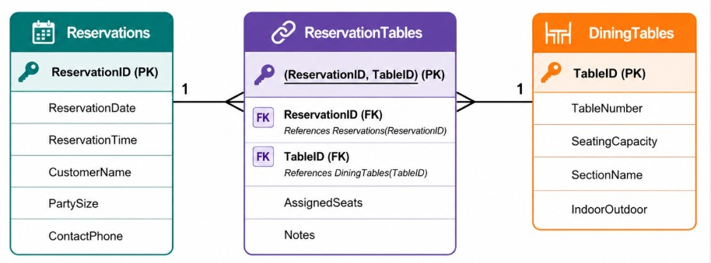
a. Identify the associative entity
• ReservationTables is the associative entity. It links Reservations and DiningTables.
b. Explain why ReservationTables requires a composite primary key
• Each row represents one specific combination of ReservationID and TableID; the composite key (ReservationID, TableID) uniquely identifies each table assigned to a reservation.
c. Identify the relationships
• Reservations has a one-to-many relationship with ReservationTables; DiningTables has a one-to-many relationship with ReservationTables; Reservations and DiningTables have a many-to-many relationship resolved by ReservationTables.
d. Describe the cardinality between Reservations and DiningTables
• Many-to-many: a reservation may use one or more dining tables, and a dining table may be used for many reservations over time.
e. Explain how this design prevents duplicate reservations
• The composite primary key (ReservationID, TableID) does not allow the same combination to be entered more than once, preventing duplicate table assignments for the same reservation.

